Project Design Phase
Solution Architecture

Date | 30 September 2026
Team ID | SWTID-2026-7743
Project Name | AI FAQ Assistant API
Maximum Marks | 4 Marks

Solution Architecture:
Solution architecture is a complex process – with many sub-processes – that bridges the gap between business problems and technology solutions. Its goals are to:
- Find the best tech solution to solve existing business problems.
- Describe the structure, characteristics, behavior, and other aspects of the software to project stakeholders.
- Define features, development phases, and solution requirements.
- Provide specifications according to which the solution is defined, managed, and delivered.

Solution Architecture Diagram – AI FAQ Assistant API:

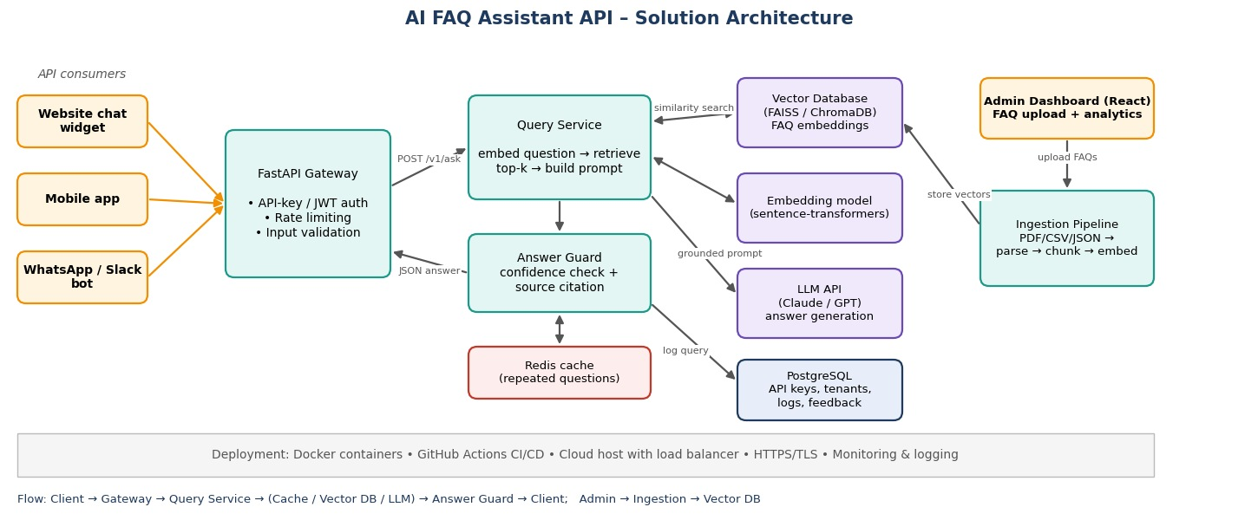
Figure 1: Architecture and data flow of the AI FAQ Assistant API
Data flow: (1) An API consumer (website widget, mobile app or bot) sends a question with its API key. (2) The FastAPI gateway authenticates, rate-limits and validates the request. (3) The query service checks the Redis cache, otherwise embeds the question and searches the vector database. (4) The top matching FAQ chunks are sent to the LLM in a grounded prompt. (5) The answer guard checks confidence and attaches the source FAQ, or returns a fallback message. (6) The question, answer and feedback are logged in PostgreSQL. Admins upload FAQ files through the dashboard; the ingestion pipeline parses, chunks and embeds them into the vector database.

